ADVANCE MATHEMATICAL FUNCTION CALCULATOR

CODE:

#!/usr/bin/python

# -*- coding: utf-8 -*-

# Advanced Mathematical Functions Calculator

# Banking Operations

# This function finds the Annual Percentage Yield

# r is stated annual interest rate

# n is number of times compounded

# This function finds the loss

def loss(s, c):

return c - s

def ctof(c):

return c * 9 / 5 + 32

# This function converts temperature from celsius to kelvin

def ctok(c):

return c + 273.15

# This function converts temperature from fahrenheit to celsius

def ftoc(f):

return (f - 32) * 5 / 9

# This function converts temperature from fahrenheit to kelvin

def ftok(f):

return (f - 32) * 5 / 9 + 273.15

# This function converts temperature from kelvin to celsius

def ktoc(k):

return k - 273.15

# This function converts temperature from kelvin to fahrenheit

def ktof(k):

return k - 273.15

# Operations related to measurements

# This function finds area of circle

# r is radius of the circle

def area_circle(r):

return 3.147 * a * a

# This function finds area of square

# x is the one of the side of the square

def area_square(x):

return x * x

# This function finds perimeter of square

# a is side of the square

def peri_square(a):

return 4 * a

# This function finds perimeter of circle

# r is radius of the circle

def peri_circle(r):

return 2 * 3.147 * r

# This function finds area of triangle

# h is height of the triangle

# b is base of the triangle

def area_triangle(h, b):

return h * b / 2

# This function finds area of rectangle

# a is smaller side of rectangle

# b is larger side of rectangle

def area_rectangle(a, b):

return a * b

# This function finds perimeter of rectangle

# l is length of the rectangle

# w is width of the rectangle

def peri_rectangle(l, w):

return 2 * (l + w)

# This function finds perimeter of triangle

# a is first side of the triangle

# b is second side of the triangle

# c is third side of the triangle

def peri_triangle(a, b, c):

return a + b + c

print ('Select operation:')

print ('4.loss')

print ('7.ctof')

print ('8.ctok')

print ('9.ftoc')

print ('10.ftok')

print ('11.ktoc')

print ('12.ktoc')

print ('13.area_circle')

print ('14.area_square')

print ('15.peri_square')

print ('16.peri_circle')

print ('17.area_triangle')

print ('18.area_rectangle')

print ('19.peri_triangle')

print ('20.peri_rectangle')

while True:

# Take input from the user

choice = input('Enter choice: ')

# Check if choice is one of the four options

if choice in (

'7',

'8',

'9',

'10',

'11',

'12',

'13',

'14',

'15',

'16',

):

num1 = float(input('Enter first number: '))

if choice == '7':

print (ctof(num1))

elif choice == '8':

print (ctok(num1))

elif choice == '9':

print (ftoc(num1))

elif choice == '10':

print (ftok(num1))

elif choice == '11':

print (ktoc(num1))

elif choice == '12':

print (ktof(num1))

elif choice == '13':

print (area_circle(num1))

elif choice == '14':

print (area_square(num1))

elif choice == '15':

print (peri_square(num1))

elif choice == '16':

print (peri_circle(num1))

break

elif choice in (

'4',

'17',

'18',

'20',

):

num1 = float(input('Enter first number: '))

num2 = float(input('Enter second number: '))

if choice == '4':

print (loss(num1, num2))

elif choice == '17':

print (area_triangle(num1, num2))

elif choice == '18':

print (area_rectangle(num1, num2))

elif choice == '20':

print (peri_rectangle(num1, num2))

break

elif choice in ('19'):

num1 = float(input('Enter first number: '))

num2 = float(input('Enter second number: '))

num3 = float(input('Enter third number: '))

if choice == '19':

print (peri_triangle(num1, num2, num3))

break

else:

print ('Invalid Input')PEP8 ONLINE CHECK:

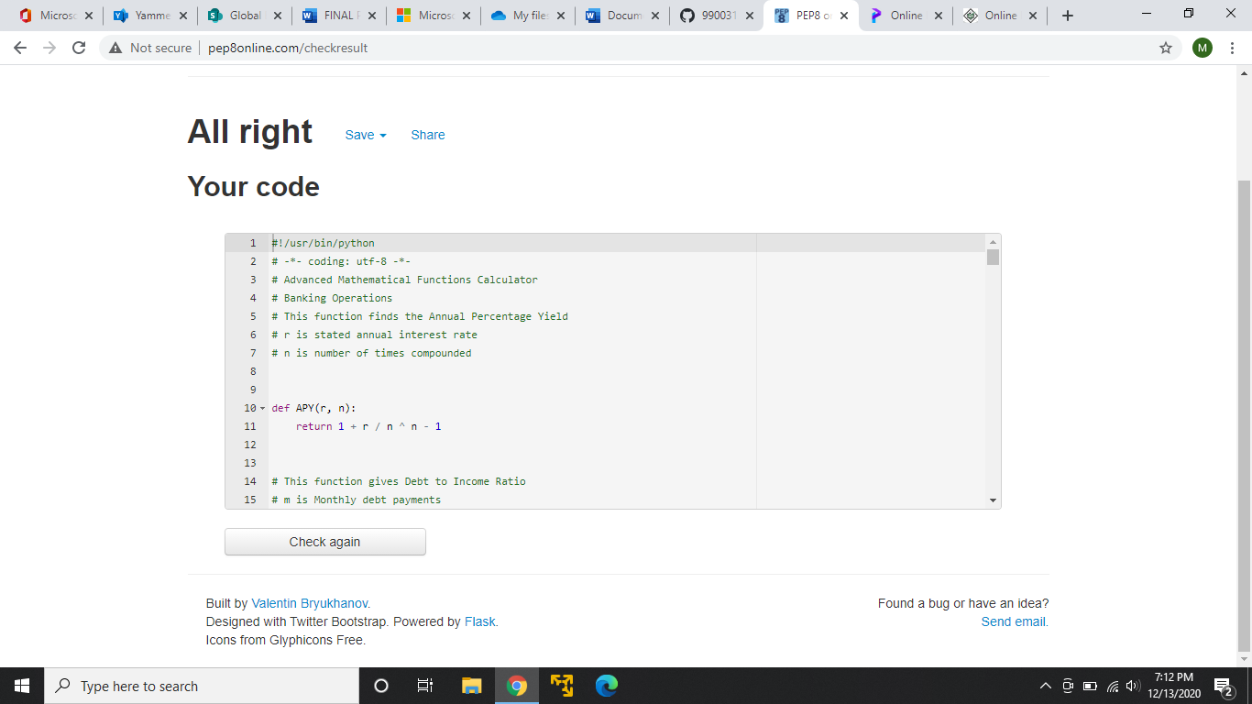

GITHUB LINK: https://github.com/99003154/Python.Mini